
CIS096-1 - Principles of Programming and
Data Structures
A Java-Based Football Club Management System for Addressing Financial Inequality

Introduction
This report outlines the detailed problem analysis and proposed system design for the Football Club Management System developed in this project. The project addresses the challenges faced by lower-league football clubs in managing financial records and player performance data effectively. Many smaller clubs operate with limited technological support, which can lead to inefficient data handling and poor decision-making.
The purpose of this document is to analyse the problem domain in detail and translate it into structured system requirements. It outlines the functional and non-functional requirements of the system, presents the use case and class diagrams, and justifies the chosen design approach. This analysis forms the foundation for the implementation phase of the project in Week 9.

Problem Domain
Lower-league football clubs often operate with limited financial and technological resources compared to elite teams. While larger clubs utilise advanced management systems and data analytics tools to monitor finances and evaluate player performance, smaller clubs frequently rely on basic spreadsheets or manual record-keeping methods. These approaches can result in inefficient data organisation, difficulty tracking financial transactions, and limited insight into player contributions.
Without a structured system, it becomes challenging for club administrators to maintain accurate financial records, monitor budgets, and assess player performance consistently. This lack of organisation can lead to poor financial decisions and reduced competitiveness over time. Therefore, there is a need for a simple, structured software solution that supports effective data management and improves operational efficiency within financially constrained football clubs.

Stakeholders
The primary stakeholders involved in this system include:
Club Administrator – Responsible for managing player records, entering financial transactions, and generating reports. This user will interact directly with the system on a regular basis.
Team Manager – Interested in reviewing player performance statistics to support team selection and performance evaluation.
Financial Officer – Responsible for monitoring income, expenses, and overall budget balance to ensure financial sustainability.
Each stakeholder requires accurate and organised information to support decision-making within the club.

Non-Functional Requirements
Non-functional requirements describe the quality attributes and constraints of the system.
The system shall:
- Be developed using Object-Oriented Programming principles, including encapsulation, abstraction, inheritance (where applicable), and modular design.
- Provide a user-friendly console interface that is clear and easy to navigate.
- Maintain data accuracy during program execution.
- Be structured in a way that allows future expansion, such as adding new features or additional data fields.
- Operate without requiring external databases or internet connectivity.
These non-functional requirements ensure that the system is reliable, maintainable, and suitable for beginner-level Java development.

Use Case Diagram for the Football Club Management System
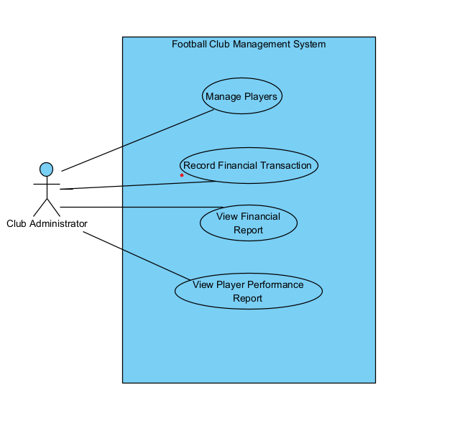

This use case shows the interaction between the Club Administrator and the system. The administrator is responsible for managing player data, recording financial transactions, and generating financial and performance reports. These use cases represent the core functional requirements identified during the problem analysis phase.

Class Diagram for the Football Club Management System

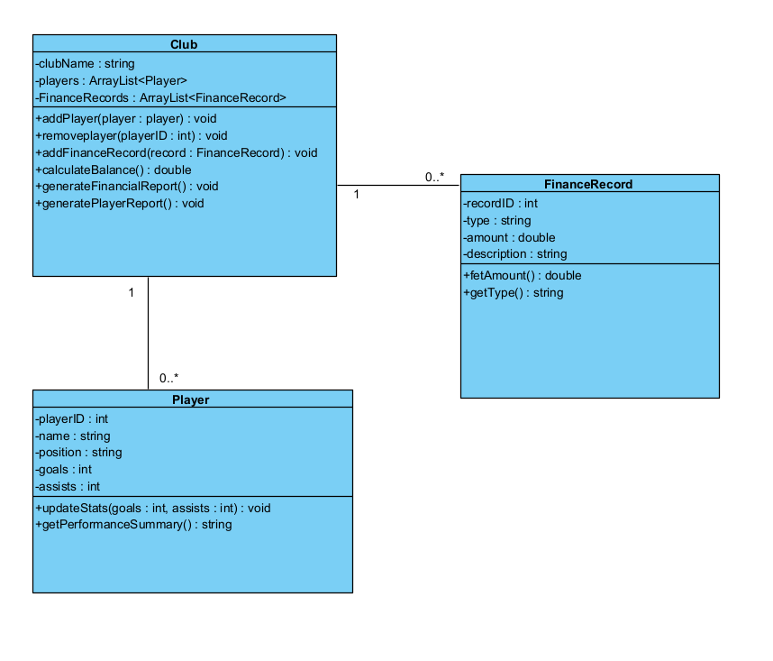

This class diagram presents the structural design of the proposed Football Club Management System. The system is composed of three primary classes: Club, Player, and FinanceRecord. The Club class acts as the central component, responsible for managing both player data and financial records. It maintains associations with multiple Player and FinanceRecord objects, as indicated by the multiplicity relationship of 1 to 0..*, meaning that a single club can manage multiple players and financial transactions.
The Player class encapsulates individual player attributes such as identification number, position, and performance statistics. The FinanceRecord class represents financial transactions, storing details including transaction type, amount, and description. All attributes are defined as private to ensure encapsulation, while public methods provide controlled access to system functionality. This structure reflects object-oriented design principles and supports modularity, maintainability, and future system expansion.

Design Patterns and Design Principles
The system design follows fundamental object-oriented design principles rather than complex formal design patterns.
The structure reflects principles of encapsulation, where class attributes are hidden and accessed through public methods. The Club class functions as a coordinating component responsible for managing related objects, resembling a simplified controller-style structure. Each class has a clearly defined responsibility: Player handles performance data, FinanceRecord manages transaction information, and Club coordinates overall system operations.
This separation of concerns improves maintainability and allows for potential future expansion, such as integrating a graphical user interface or persistent data storage.

Technological Stack
The proposed technological stack for this project includes:
- Programming Language: Java
- Development Environment: BlueJ
- Modelling Tool: Visual Paradigm
- Diagram Standard: UML
Java has been selected due to its strong support for object-oriented programming concepts. BlueJ is used as it provides a beginner-friendly environment suitable for learning and testing object-oriented systems. Visual Paradigm is utilised for creating professional UML diagrams that clearly represent system structure and behaviour.

